20/09/2024

Torin Flanagan

Student ID: 1169130

DIG202 Digital Dashboard

Task 2

Table of Contents

1. Introduction 2

2. Plan 3

3. Scope 4

4. Design 5

5. Develop and Test 12

6. Launch 14

7. References 15

8. Appendices 16

# Table of Figures

Figure 1 (sales report design): 6

Figure 2 (shipping report design): 8

Figure 3 (inventory report design): 10

Figure 4 (sales data report): 12

Figure 5 (shipping data report): 12

Figure 6 (inventory data report): 13

Figure 7 (final dashboard): 13

Figure 9 (first 10 sales data rows): 16

Figure 8 (first 10 shipping data rows): 16

Figure 10 (first 10 inventory data rows): 16

# 1. Introduction

I acknowledge the use of Chat GPT in this assessment for proofreading my work.

Jonathon Briggs, CEO of Itikan, an Australian eCommerce company, has requested help to improve data analysis as the business grows. He manages sales, inventory, and shipping data, but currently receives it from various departments in different formats, requiring manual adjustments. His focus is on tracking sales, profitability, inventory, picking times, and delivery costs for 1% of orders from August to October. The provided data includes sales, shipping, and inventory, already processed through the ETL process, with additional columns created from existing data. Jonathon prioritizes monitoring monthly profit percentage to assess pricing effectiveness. To streamline analysis, I will create a Power BI dashboard offering real-time views of sales, shipping, and inventory data, with detailed reports for each. Power BI is a tool provided from Microsoft that is able to transform raw data from multiple sources into actionable insights (Coursera, 2023).

# 2. Plan

**What are you aiming to deliver?**

I aim to deliver a detailed Power BI dashboard for Jonathon Briggs, CEO of Itikan, with an intuitive interface to monitor key performance metrics. The dashboard will provide real-time analysis of sales, shipping, and inventory data, with a focus on tracking monthly profit percentages to assess product pricing. It will allow Jonathon to drill down into detailed reports for deeper analysis, while upfront displaying essential data. By integrating data from various departments and automating processes, the dashboard will improve decision-making and eliminate the need for manual adjustments.

**When are you aiming to deliver this?**

The target delivery date for the Power BI dashboard is September 20th. Since this is a sample case study and Jonathon is fictional, there’s no actual timeline. In a real scenario, the first version would be ready for review in two weeks, allowing feedback from Jonathon. The final version, incorporating all feedback and refined visualizations, would follow after adjustments.

# 3. Scope

**Purpose/objective of dashboard**

The dashboard aims to streamline data analysis and support Jonathon Briggs in making informed decisions as the company expands. Currently, data from different departments require manual adjustments. This dashboard will consolidate key metrics, allowing Jonathon to monitor critical business aspects at a glance and drill down into detailed reports as needed.

**How dashboard will support decision-making**

The dashboard will provide real-time insights on sales, inventory, and shipping, enabling Jonathon to make data-driven decisions to improve operations and identify growth opportunities. Automated data processing will eliminate manual work, offering consistent and up-to-date information for quick decision-making.

**What are the objectives of the CEO and how does the dashboard link to this?**

1. Sales Performance: Tracks product performance to ensure revenue goals are met.
2. Profitability: Monitors monthly profit percentages to evaluate pricing effectiveness.
3. Inventory Levels: Ensures optimal stock levels to meet demand without overstocking.
4. Picking Time: Monitors warehouse efficiency to reduce operational delays.
5. Delivery Costs: Manages shipping costs to maintain profitability and customer satisfaction.

**Measurements CEO is interested in**

1. Sales Volume and Revenue: Shows product sales performance over time.
2. Profit Percentage by Month: Indicates pricing effectiveness and need for adjustments.
3. Inventory Levels: Displays turnover rates and stock levels to meet demand.
4. Delivery Costs: Breaks down shipping costs to assess their impact on profitability.

**Summary**

Monitoring these key metrics through the dashboard will help Jonathon ensure smooth operations and make better strategic decisions on pricing, sales, shipping, and inventory management as the company grows.

# 4. Design

**Types of visuals and why for sales data**

Bar Chart:

* A bar chart displaying order profit by customer helps visualize which customers generate the most profit for the company.
* A bar chart showing profit margin by category highlights profitability across different segments, offering insights into overall performance.

Pie Chart:

* A pie chart for order distribution by channel (Amazon, eBay, Trade Me, Website) reveals which sales channels contribute the most to total orders, indicating their effectiveness.

Line Chart:

* A line chart tracking order profit by date helps identify trends in profitability over time, showing whether profits are increasing, decreasing, or stable.

Scatter Plot:

* A scatter plot showing order subtotal against profit margin reveals how order size impacts profitability, providing insights into pricing and profitability strategies.

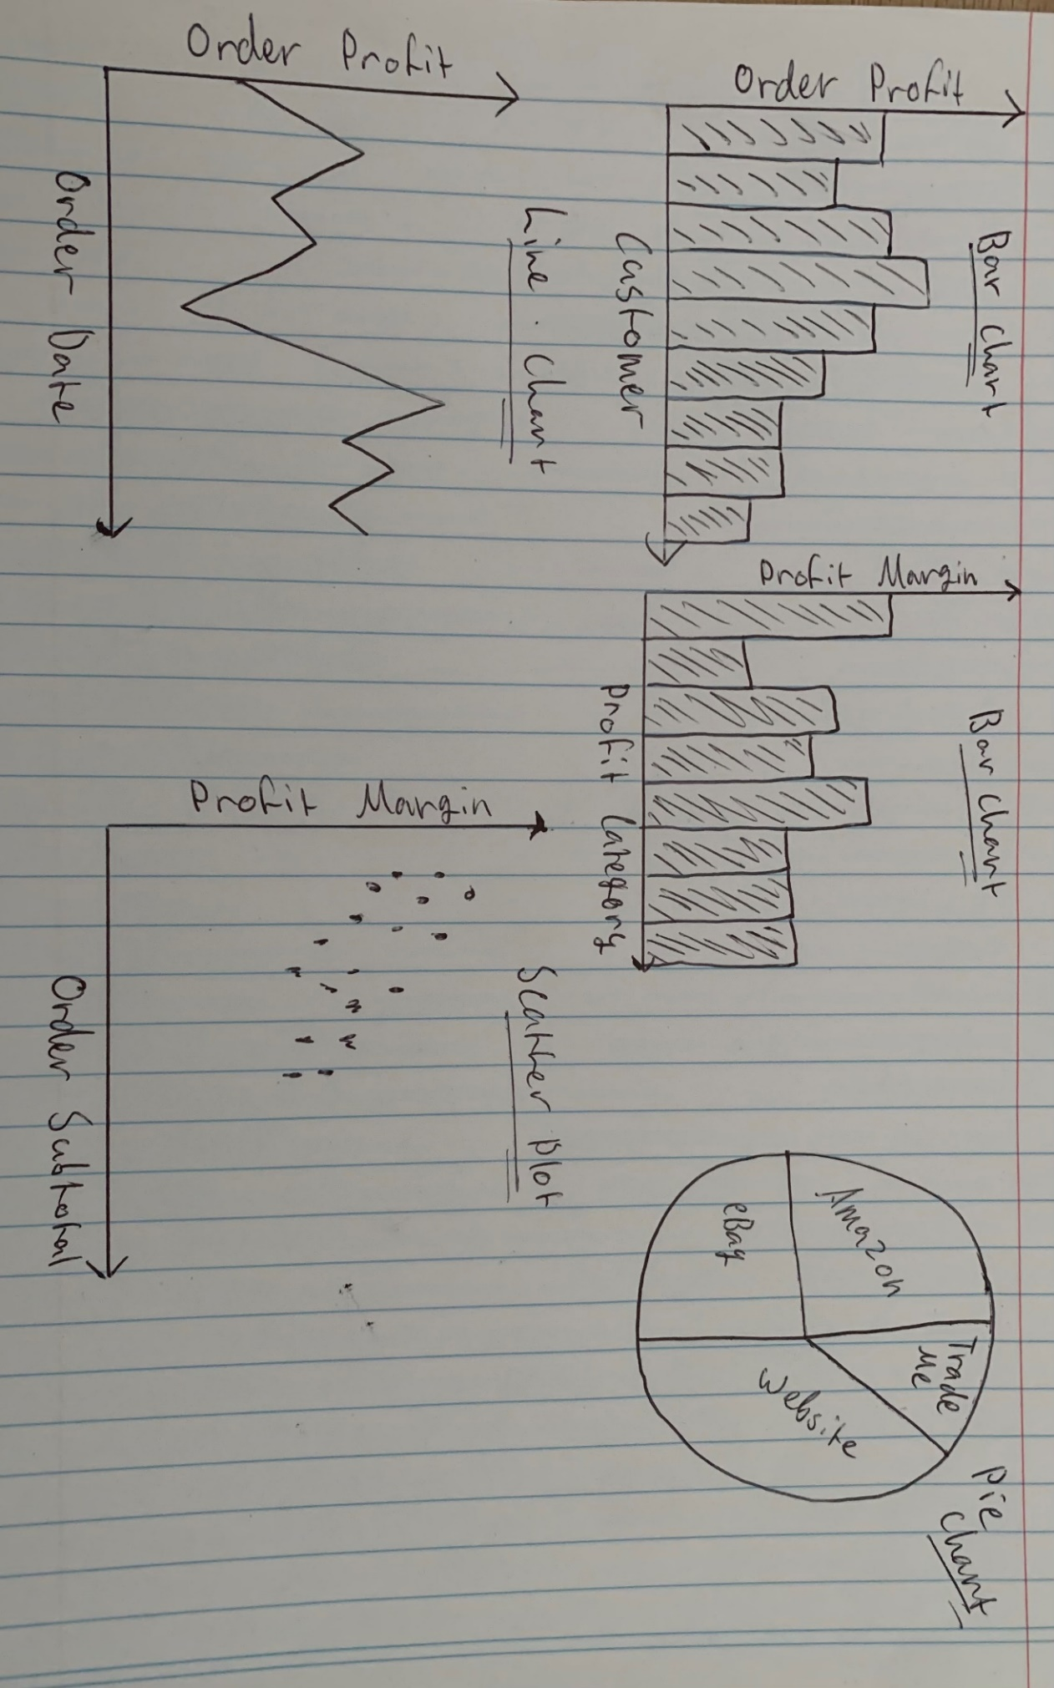

Figure 1 (sales report design):

**Types of visuals and why for shipping data**

Scatter Plot:

* A scatter plot of days to pick versus shipping cost can reveal relationships between order picking time and associated shipping costs.
* A scatter plot comparing days to ship and shipping cost highlights potential inefficiencies in shipping times that may contribute to increased costs.

Stacked Bar Chart:

* A stacked bar chart for order processing speed by shipping speed compares the efficiency of order processing and shipping, offering insights for operational improvement.

Pie Chart:

* A pie chart showing shipping costs by method visualizes the proportion of costs for each shipping type, helping assess cost efficiency and identify overpriced methods.

Histogram:

* A histogram of days to pick versus days to ship visualizes the distribution of time taken for both stages, providing insight into whether orders are processed within acceptable timeframes.

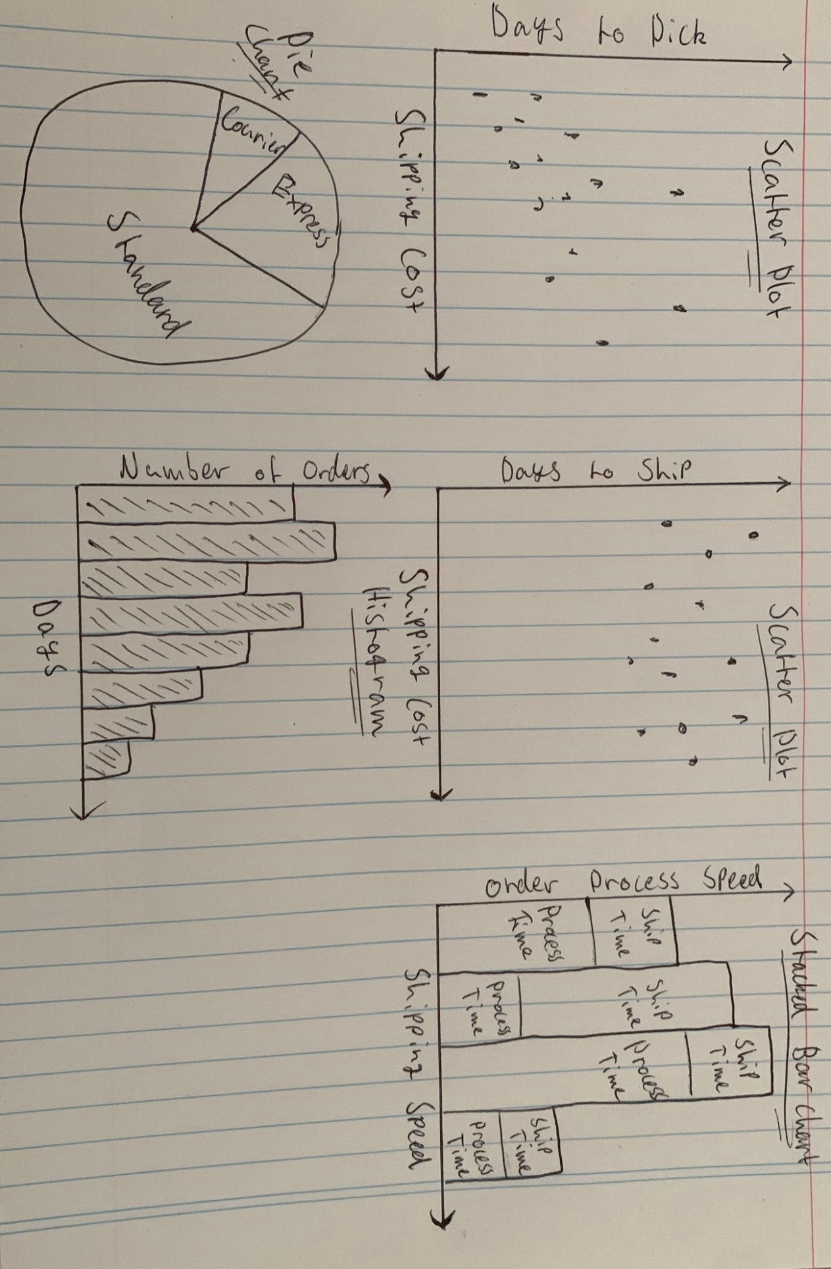

Figure 2 (shipping report design):

**Types of visuals and why for inventory data**

Line Chart:

* A line chart tracking total inventory (Inv Cat A + B + C) by order date shows daily inventory trends, highlighting periods of low inventory or rapid depletion.

Clustered Column Chart:

* A clustered column chart comparing total inventory to low stock levels provides a clear view of how much inventory is nearing low stock status, aiding in stock management.

Stacked Bar Chart:

* A stacked bar chart displaying Inv Cat A, B, and C by order date allows for quick comparison of stock levels across categories and identifies which category depletes fastest.

Pie Chart:

* A pie chart showing the percentage distribution of Inv Cat A, B, and C on a given date visualizes how inventory is divided across categories.

Bar Chart:

* A bar chart comparing total inventory by stock status over time highlights overall inventory levels, with each bar representing the stock status, making it easy to track inventory fluctuations.

Figure 3 (inventory report design):

**Data quality and transformations**

The overall data quality of the three provided data sheets was largely compliant with ETL standards, though some minor errors were addressed to align with the format. From the sales data sheet, we added variables such as profit margin, shipping tax, and profit category. In the shipping data sheet, we incorporated order processing speed, shipping speed, and the time from pick to ship. Finally, the inventory data sheet was enhanced with variables including total inventory, total low stock, and stock status.

# 5. Develop and Test

Figure 4 (sales data report):

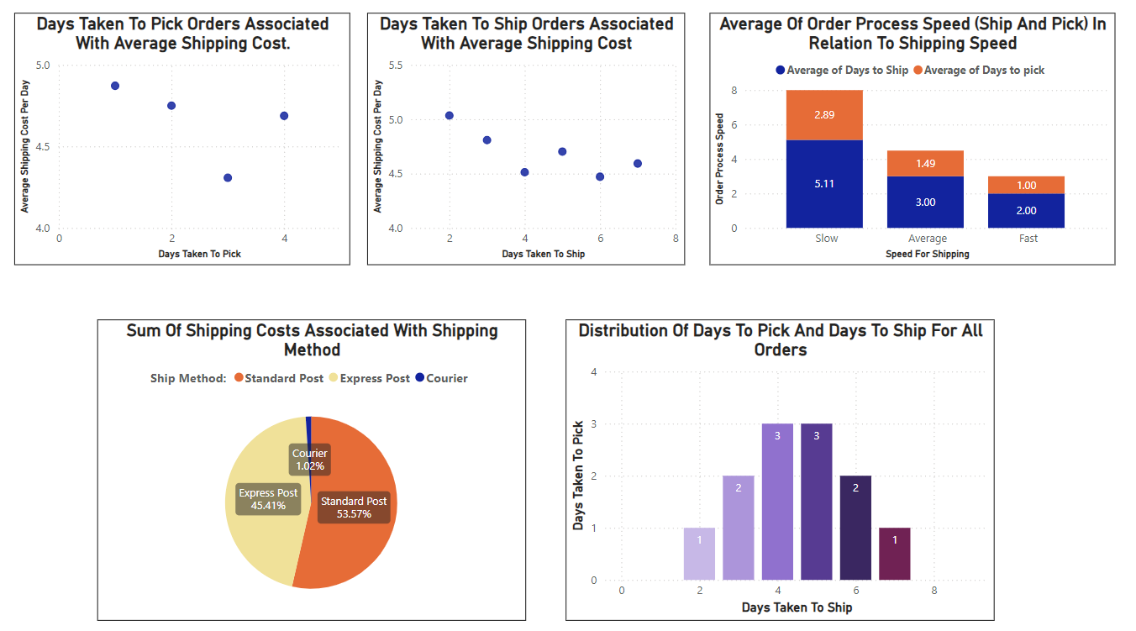

Figure 5 (shipping data report):

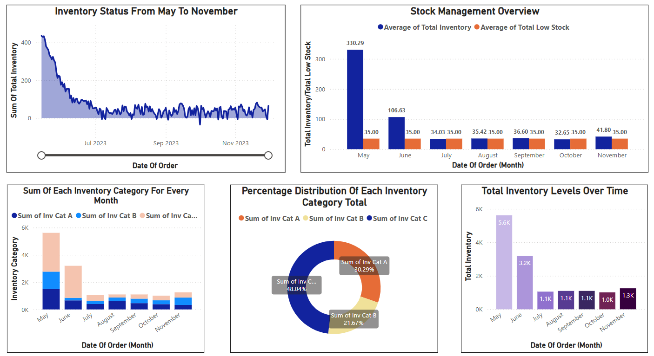

Figure 6 (inventory data report):

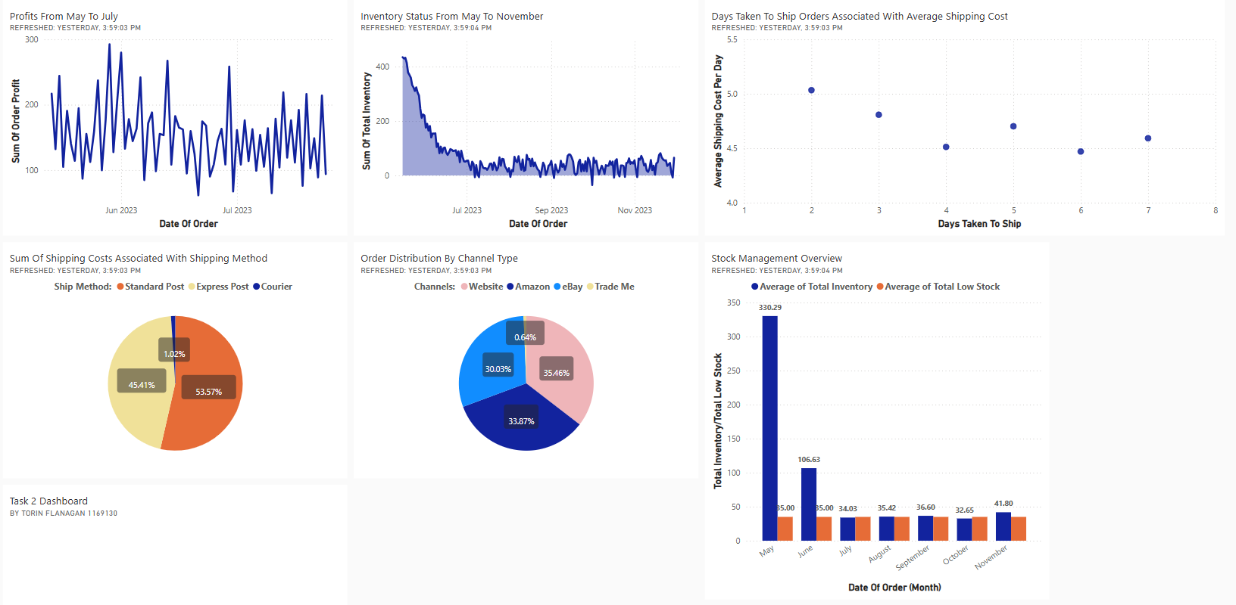

Figure 7 (final dashboard):

# 6. Launch

The dashboard development involved creating data reports for sales, shipping, and inventory, then pinning visuals that best matched Jonathon Briggs’ requests. Although I followed my original designs closely, some changes were made during development. For the sales report, I limited the bar chart to the top 10 customers by profit, as displaying all customers overcrowded the visual. In the shipping report, I corrected an axis error in the scatter plots, placing "days to ship" and "days to pick" on the x-axis instead of the y-axis. For the inventory report, I switched from a pie chart to a donut chart for a cleaner look and adjusted the bar chart to show total inventory per month instead of just stock status (OK/Low).

Once the reports were complete, assembling the dashboard was straightforward. From the sales report, I used the line chart to display daily profits and the pie chart to show customer channel types. For the shipping report, the pie chart highlighted the most-used shipping methods, while the scatter plot visualized shipping costs versus time. Finally, from the inventory report, I included the line chart for inventory trends from May to November and the clustered column chart to show total inventory by month, focusing on low stock levels.

# 7. References

* Coursera. (2023, June 16). *What Is Power BI? What It Is, How It’s Used, and More*. Coursera. <https://www.coursera.org/articles/what-is-power-bi>
* *Visual Analysis Best Practices Simple Techniques for Making Every Data Visualization Useful and Beautiful*. (n.d.). <https://www.tableau.com/sites/default/files/media/whitepaper_visual-analysis-guidebook_0.pdf>

# **A screenshot of a computer**8. Appendices

Figure 9 (first 10 sales data rows):

Figure 8 (first 10 shipping data rows):

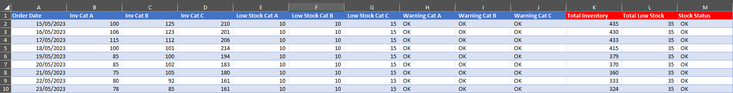

Figure 10 (first 10 inventory data rows):